
Social Media Toolkit
A new statewide public opinion poll conducted by KRC Research on behalf of the Texas Library Association confirms what many already see every day: Texans overwhelmingly value public libraries as essential public services.
At a time when public discourse has questioned the relevance of libraries and the role of librarians, the data tells a very different story: Texans across political perspectives and demographics strongly support their libraries, trust library professionals, and believe in maintaining broad access to information.
Show your support for Texas public libraries by sharing how they have supported you or your community on social media!
Use the graphics and text below to promote the study findings with your online network!
Images are JPEGs. Click to open, right click to download: Image 1 | Image 2

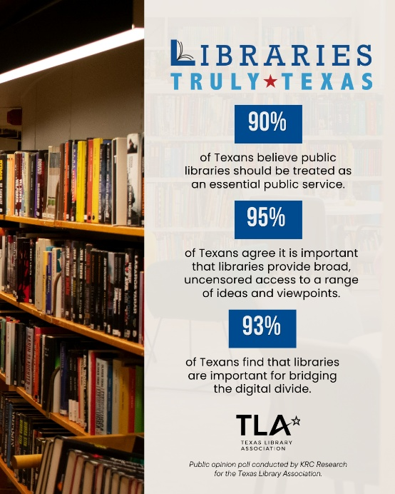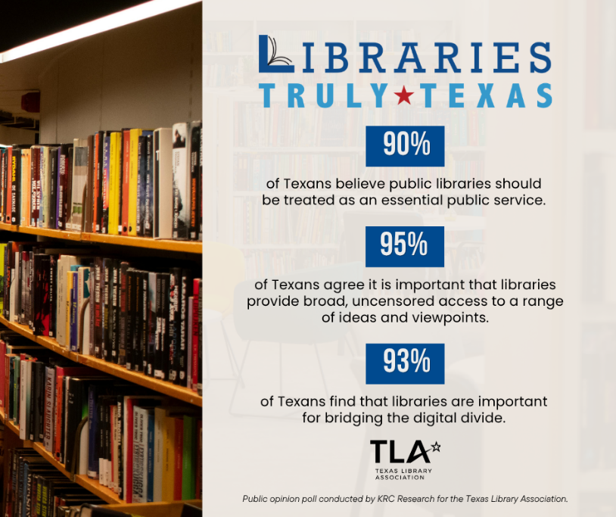
Image 1: Instagram/LinkedIn Image 2: Facebook/X

Show Your Support for Texas Libraries
- While there are ongoing conversations questioning the role of libraries, the reality in our community is clear: we rely on and value them. The Texas Library Association’s recent statewide public opinion poll shows that this sentiment is shared across the state. I invite you to explore the results and share what your library means to you. txla.org/opinion-poll-results #LibrariesTrulyTexas
Public Libraries, Share with Your Online Audience:
- The (Insert Public Library Name) is committed to showing up for our community, from everyday services to programming that connects and supports patrons. What we see in everyday practice is clear—our community relies on and values us. The Texas Library Association’s statewide public opinion poll shows that this belief is shared statewide. Explore the results and join us in sharing what our library means to you. txla.org/opinion-poll-results #LibrariesTrulyTexas #SupportTXLibraries

- The (Insert Public Library Name) is proud to provide access to information, opportunities for our community, and a place to belong. As discussions about the role of libraries grow, communities across Texas continue to rely on them in meaningful and consistent ways. The new Texas Library Association statewide public opinion poll reflects what we see every day—Texans trust and value their libraries. Has our library positively impacted your life? Share your story with us in the comments. txla.org/opinion-poll-results #LibrariesTrulyTexas

